**Stat 5870, section 2 Lab 3**

**Goals:**

Learn how to use JMP journals to save output.

Computing two-sided t-tests

**Lab Activities**

We will (for the last time) use the creativity dataset, one of the Chapter 1 case studies.

Note: The lab notes will only explain / interpret new material. Reading the data set is explained in the lab 1 and lab 2 notes.

**Journals:**

A journal is JMP’s way to collect desired output in one place. This can then be exported to a Word file.

To start a journal, File / New / Journal. A window will open showing the contents of the journal.

This will be blank to start.

You then run the desired analyses. To save that window or graph in the journal, either:

select that window and type ctrl-j (the keyboard shortcut), or

find the menu under the thin blue bar in that window, Edit / Journal

either way, the contents of that window are added to the journal. You should see them in the journal window.

You continue through your analyses, adding the ones you want to keep to the journal.

You can even put a copy of the data set into the journal (by entering the contents of the data window into the journal).

To save the journal as something that Word can work with:

Select the journal window, File / Save As

The window title should be Save Journal As. If not, you’re saving the wrong window.

Navigate to the desired folder, Choose a file name, then change Save as type to rtf. RTF format files are a Word format. At least in JMP 17 Pro, JMP does not offer the option of a Word (.docx) format.

If you choose save, JMP will save the journal using its internal .jm format. This allows you to save a journal and come back later to load the save journal and continue adding results to it. Word doesn’t (as far as I know) read .jm files.

If there are plots in your journal, you will be asked for the graphics file format.

On a Windows machine, I recommend the .emf format

On a Mac or Unix machine, I recommend the .tiff format

**Two-sample t-tests, assuming equal variances**:

Once the data are read in, Analyze / Fit Y by X, put the response variable into the Y, Response box and the grouping variable into the X, Factor box. The window should look like:

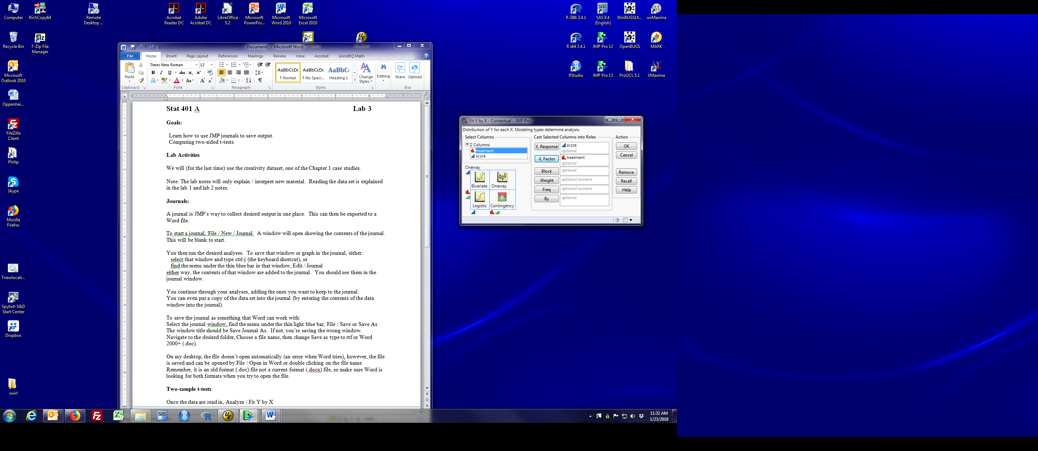

Note that the Y variable is continuous (blue ramp) and the X variable is nominal (red bar). Remember the discussion of modeling type in week 2’s lab. If you have the wrong modeling types, or reverse the roles of Y and X, the next dialog will look completely different (and will not be running a t-test).

Click the red triangle by Oneway Analysis of score by treatment. You should see:

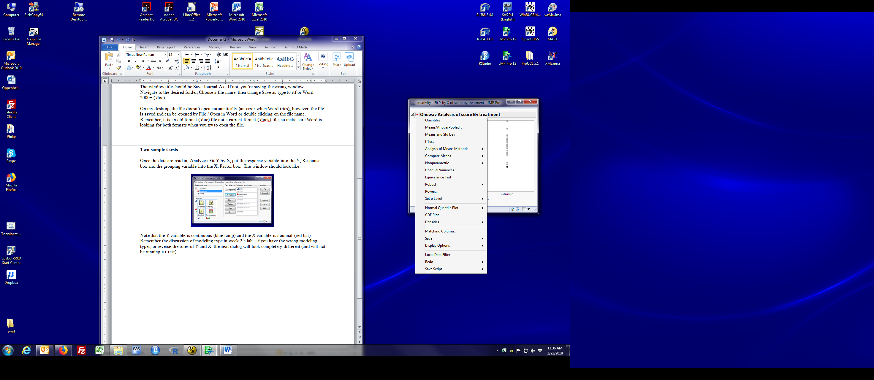

Select **Means / Anova / Pooled t.** This implements the pooled t-test.

If you select t-test, you get the unequal variance (Welch) t-test instead. We’ll talk about the difference in lecture. In all the fields PMD works in, the pooled t-test is the customary approach.

WARNING: If you want the usual T test, make sure to select **Means / Anova / Pooled t**, not t-Test. The only sign you’re doing a Welch t-test (unequal variances) is the note in the t Test window.

The output includes lots of numbers. Most of the one’s you might be interested in are found in the t Test box of output. Those found in some other box of results include the box info.

Quantity Labelled

Estimated difference: Difference The order is given below t Test, here intrinsic-extrinsic

se of difference Std Err Dif

pooled sd Root Mean Square Error in Summary of fit box

df for pooled sd DF

t statistic T ratio

two sided p-value Prob > |t| (here 0.0060)

95% confid. interval for diff Upper CL Dif and Lower CL Dif

means for each group Mean column in Means for Oneway Anova box

se for each mean Std Error column in Means for Oneway Anova box

95% conf. ints for means Lower 95% and Upper 95% in Means for Oneway Anova box

**Estimating 90% or 99% confidence intervals**

The easiest way to change the confidence interval coverage (e.g. to 90% or 99%) is to click Set α level (the 12’th item in the list shown above). α is 1-the coverage. If you want 90% intervals, choose α = 0.10; 99% intervals, α = 0.01. You can do this before or after you run the t-test. If after, the appropriate numbers and table legends are updated.

If you aren’t sure what coverage has been used, the Confidence value in the t Test box will tell you.